BEFORE -
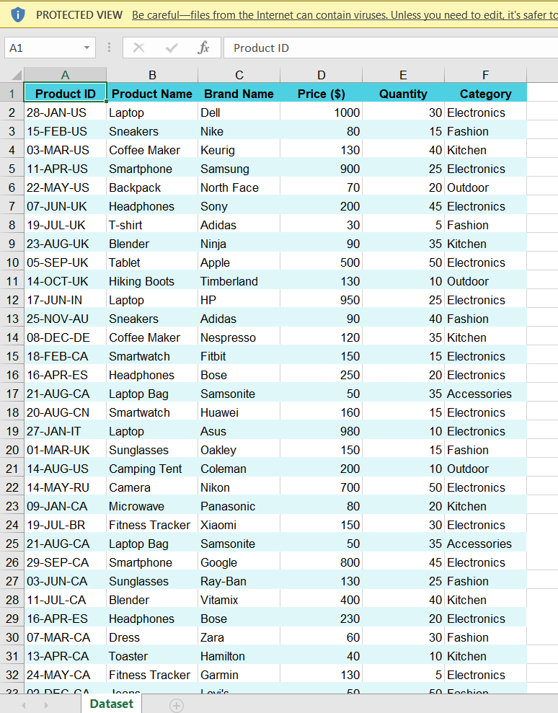

AFTER –

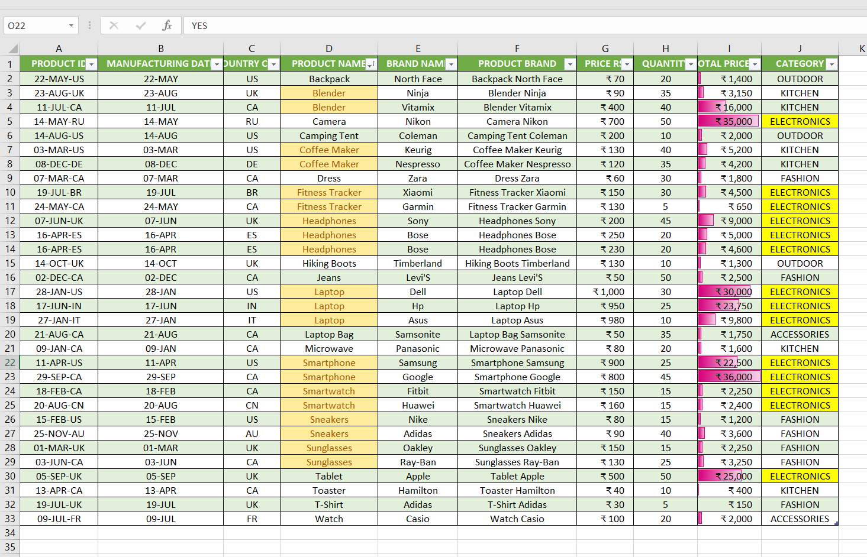

FINDINGS AND FORMULAS –
TASKS | SUMMARY | FORMULAS & FINDINGS
HANDLING MISSINGS VALUES | 1)THERE IS NO MISSING VALUES IN PRICE COLUMNS | 0
 | 1)NO MISSING VALUES IN CATEGORY COLUMNS ALSO | 0
CORRECTING INCONSISTENT DATA | NO INCONSISTENT DATA | NO
REMOVING DUPLICATES | 1)FOUND DUPLICATE ENTRIES APPEARS TWICE IN ROWS AND REMOVED THE SAME . | ROWS 16 & 24
 | 2)I KEPT BOTH ROWS 15 AND 28 , WHICH IS DIFFER IN PRICE RANGE | ROWS 11 & 33
1)SPLITTING DATA | SPLITTED INTO TWO COLUMNS - MANUFACTORING DATE AND COUNTRY CODE | RIGHT(A2,2) AND LEFT(A2,6)
2)MERGING DATA | MERGED TWO PRODUCT NAME AND BRAND NAME INTO ONE ( PRODUCT BRAND )COLUMNS | CONCATENATE (D2," ",E2)
NUMBER FORMATTING | 1)CHANGED PRICE COLUMN TO A CURRENCY FORMAT
 | 2)CHANGED IN DATE FORMAT BUT YEAR IS MISSING IN THAT DATASET
CONDITIONAL FORMATTING | APPLIED DATA BAR FORMATTING IN PRICE COLUMNS
 | CREATED NEW RULE IN CATEGORY COLUMNS, WHICH IS HIGHLIGHTED " ELECTRONICS":
REMOVED NULL COLUMNS AND ROW | YES
TRIM, PROPER CASE USED | YES
REMOVED DUPLICATES | YES

